3 Types of ELB.

1. Network Load Balancer( Plane LB we can access any port in Network LB)
2. Application Load Balancer (HTTP/ HTTPD ports only can able to access)
3. Classic Load Balancer

**Now Discussing Network Load Balancer**

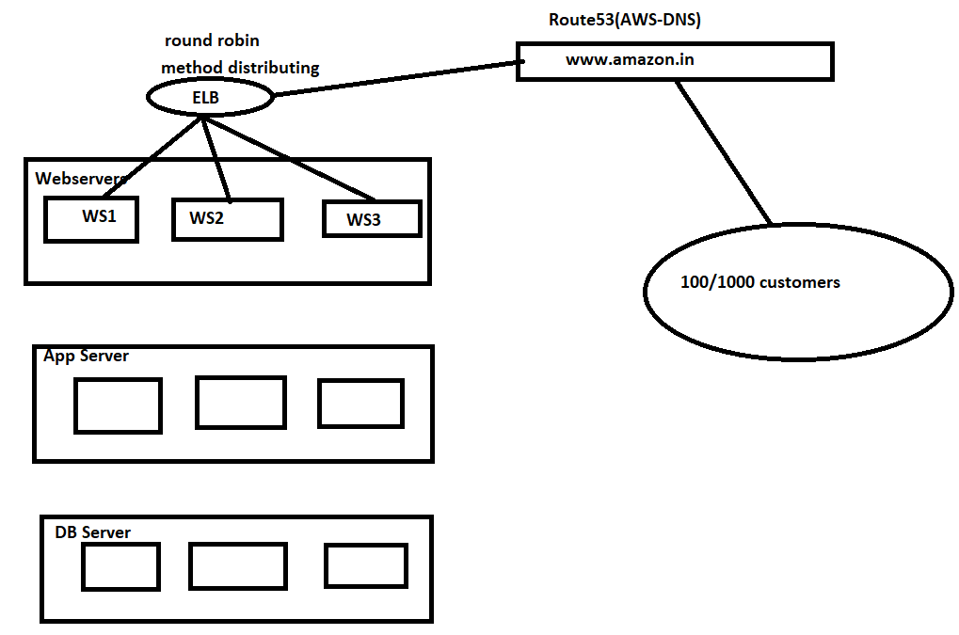

Add Cname(canonical name) in the DNS config file.(www.amazon.in)

Practical Session:-

1. Deploy 3 servers with Nginx Installed in different availability zones.
2. Looging to each server and add extra line to index.html as webserver1,2,3
3. Configure Target Groups and add only Webserver 1 & 2 only.
4. Deploy Load Balancer and add target Group
5. Check the load balance of requests are happening between the servers 1 & 2 .
6. Add the 3 rd server check the request are server 3 or not
7. Delete server 1& 2 and check servers should go to only server3



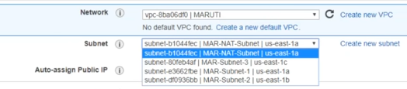

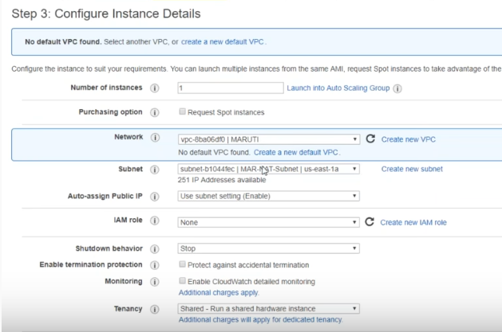

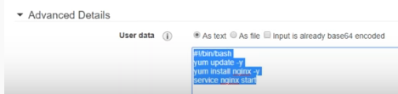

cd /usr/share/nginx/html/index.html



Target Groups is nothing but which servers we have to load balancers and up to which limit

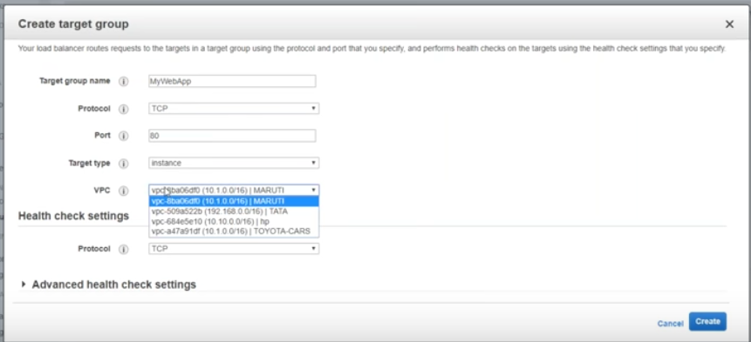

Once we placed the server in Load balancer it will check weather server is up or not by using below screenshot.  
  
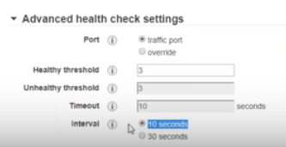

If server is not pinging for 30 sec it will declare as dead.

By setting threshold value and interval we can confirm the server pinging status in target group.

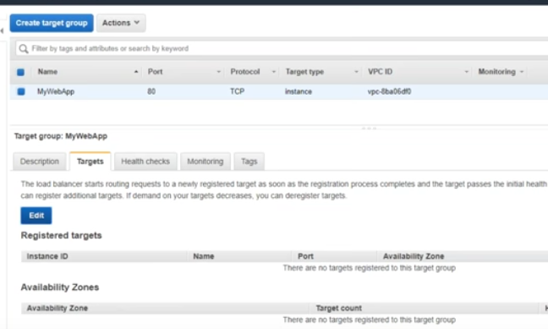

Add 1 and 2 servers by clicking on edit.

Now Create Load Balancer.

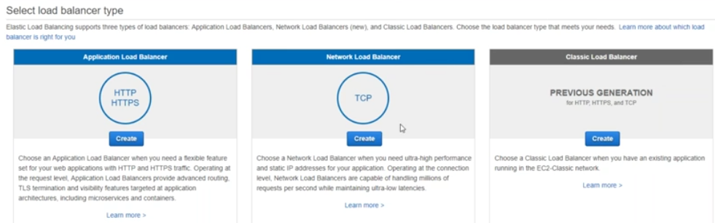

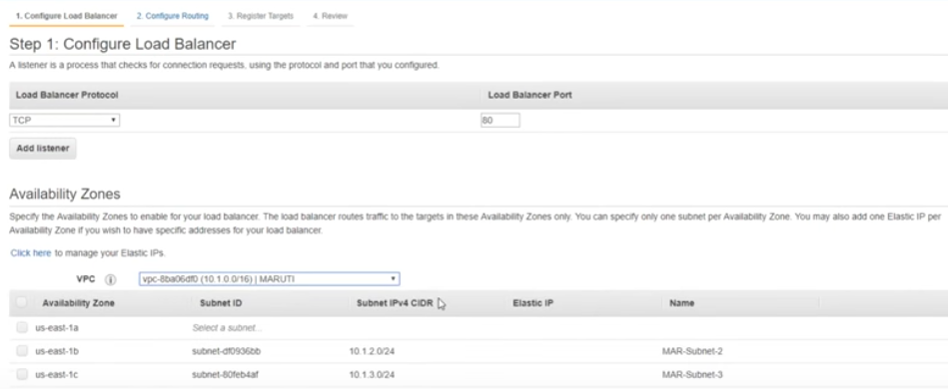

*** While deploying/creating network load balancer you must select subnets.

It is not possible to add subnets If we missed by mistakenly

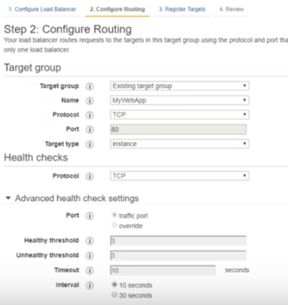

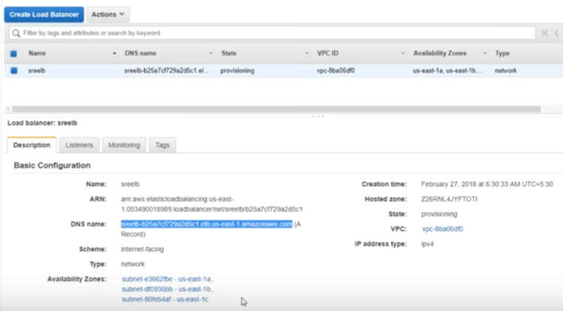

We must use with this DNS Name.

On the fly we can add machines by using target groups

Check Target group Servers health status before executing.  
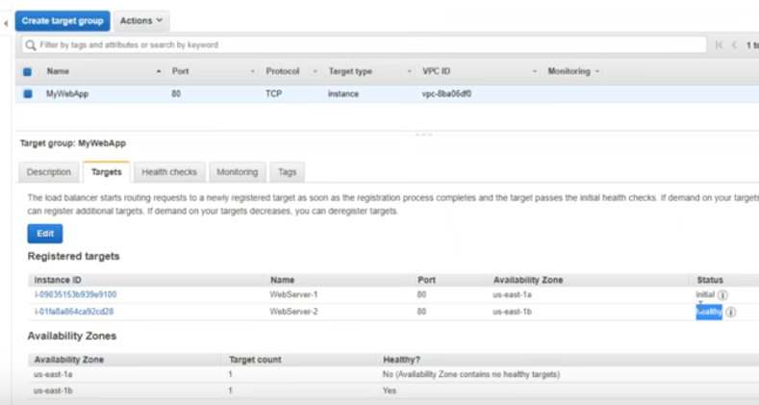

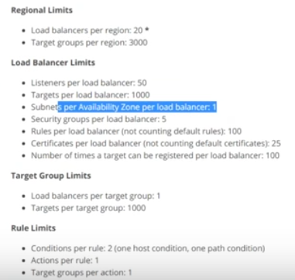

Stop nginx of 2 servers it will show you the single server.

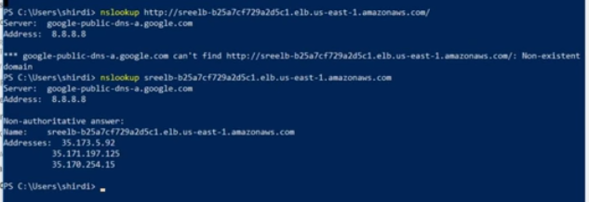

Load Balancer internally it creates the eth port and assign their own ip.